0. Overview: 1

1. Prerequisites: 1

2. Install Printer Compatible Slicing Software: 1

3. Select a Design to Print: 2

A. Do It Yourself 2

B. Use a free design 2

C. Purchase a design for use 2

4. Download the Design to a Flashdrive: 3

5. Run the slicing software: 3

6. Save the .gx code to a USB drive: 3

7. Load the Filament. 3

8. Preparing the printer bed: 4

9. Leveling the Bed 5

10. Plug USB flash drive into printer and load .gx code: 6

11. Start print: 6

12. Monitor print progress: 7

13. Print complete, remove from printer: 7

14. Print bed cleanup: 7

15. Post processing, options for finishing the print: 7

Appendix A: FlashPrint Basics 11

# Overview:

This document discussed the creation of 3D printed objects using Fused Deposition Modeling (FDM) which is a 3D printing technique that uses a heated thermoplastic filament laid down in layers by a computer-controlled print head/nozzle and bed moving in 3 axis to create a three-dimensional object.

The document focuses on using Flashforge Adventurer 3 3D printers and PLA filament, however the knowledge and techniques outlined here should be easily transferable to other FDM printers. Non-PLA filaments may require different software settings and/or techniques for post-processing.

|  |
| --- |
| **NOTE: This document DOES NOT address the creation of 3D designs using CAD (Computer Aided Drafting) or other software.** |

# Prerequisites:

1. A computer with Internet access on which software to prepare the design for printing can be installed.
2. Availability of an FDM 3D printer, printer filament (e.g. PLA), and hand tools required to remove the print from the bed and clean the bed. Optional: a glue stick or masking tape to assist in bed adhesion, chemicals such as isopropyl alcohol for use in cleaning the bed.
3. A USB flash drive (aka thumb drive) compatible with both the computer and the 3D printer (USB-A port). Depending on the devices used this may require a USB port adapter.

|  |
| --- |
| **NOTE: Flashforge Adventurer 3 printers will not recognize a flash drive larger than 32GB.** |

1. *Optional:* A utility capable of unpacking .zip or .rar files, e.g. WinZip, 7-Zip, WinRar.

# Install Printer Compatible Slicing Software:

|  |
| --- |
| **NOTE**: **At this time slicing software is not installed on the college (CCM) computers. You must install the slicing software and generate the .gx code file(s) on your own computer.** |

Slicing software is used to convert .stl 3D drawing files to .gx code files which are readable by the printer. Most 3D printer makers will provide or recommend slicing software for use with their printer.

FlashPrint from Flashforge is recommended when printing on Flashforge 3D printers. Versions of FlashPrint are available for Windows, Mac , and Linux operating systems. The FlashPrint software can be downloaded from the Flashforge website <https://flashforge.com/pages/software-flashprint>.

# Select a Design to Print:

## Do It Yourself

You may create an original 3D design or modify an existing free design (ensure you are aware of any copyright restrictions for use imparted by the original designer), This can be done using any 3D modeling software capable of generating files in the .stl format. Examples of such software are;

* Tinker CAD (Free)
* Blender (Free)
* Freecad (Free)
* AutoCAD (Paid)
* Solidworks (Paid)

## Use a free design

Many creators share their designs for free, allowing others to use them as-is, or modify them for their own use. Ensure you are aware of any copyright restrictions for use imparted by the original designer using licensing such as Creative Commons ; (<https://creativecommons.org/share-your-work/cclicenses/>).

Examples of sites where models can be downloaded for free are;

Thingiverse <https://www.thingiverse.com>

Creality World <https://www.crealitycloud.com/> (limited free designs)

MyMiniFactory <https://www.myminifactory.com/> (limited free designs)

Cults 3D <https://cults3d.com/en>

CGTrader <https://www.cgtrader.com/> (limited free designs)

TurboSquid <https://www.turbosquid.com/> (limited free designs)

Free3D <https://free3d.com/> (limited free designs)

Printables <https://www.printables.com/model>

Pinshape <https://pinshape.com>

GrabCAD <https://grabcad.com/library>

Zortrax Library <https://library.zortrax.com/>

## Purchase a design for use

Some creators require payment to use their designs. The ability to modify, re-mix, or use the designs may be governed by individual licenses found on the sites.

Creality World <https://www.crealitycloud.com/> (limited free designs)

MyMiniFactory <https://www.myminifactory.com/> (limited free designs)

CGTrader <https://www.cgtrader.com/> (limited free designs)

YouMagine <https://www.youmagine.com/>

# Download the Design to a Flashdrive:

Download the chosen design and move it to a folder where you can if necessary, unpack it using the appropriate extraction utility (e.g. WinZip, 7-Zip, WinRar). Extract the files to a separate sub-directory.

# Run the slicing software:

If the slicing software is installed double-clicking the chosen .stl file should open the slicing software and display an image of what the file should look like after 3D printing. Alternatively you can open a file using “File”, “Load file” and navigating to the file, then clicking Open. (See Appendix A for recommended changes to default settings when using FlashPrint.)

# Save the .gx code to a USB drive:

|  |
| --- |
| **NOTE: Flashforge Adventurer 3 printers will not recognize a flash drive larger than 32GB.** |

When slicing is finished click on the green down arrow in the top right of the screen and select the appropriate location (flash drive) to store the file. (See Appendix A: FlashPrint Basics)

# Load the Filament.

In order to load the filament the printer must be turned on. The power switch and the power cord connection are on the right side of the printer in the lower back corner. When turned on the display on the front of the printer will be lit up and displaying text and/or graphics.

The most common filament for use in these printers is PLA which serves as a good general purpose filament for 3D printing. Other types of filament can be used however you may need to change the parameters in the slicing software to use these filaments.

Filament is generally provided on reels which can be attached to the printer to ensure proper unspooling, without kinks or tight bends which can cause print failures. The filament is typically pushed into a heated nozzle at a defined rate by gears which grip the film.

|  |  |
| --- | --- |
| **NOTE: The filament reel holders built into the left side of the Adventurer 3 printers are not large enough to hold the filament reels used in the lab. There should be a pair of ball bearing filament reel holders for each printer on which the filament spool can be placed. The ball bearings allow the filament to unwind from the spool with minimal resistance. When finished with a spool please ensure the loose end of the filament is placed through one of the holes near the outer edge of the spook to help prevent the filament from unwinding. Loose filament on the spool can cause filament to tangle and break while printing.** |  |

Previously used filament which has been unloaded from the printer will usually have a long “string” on the end as a result of being previously heated and forced through the extruder nozzle. ***Prior to loading the filament ensure that the end of the filament is cleanly cut, ideally at a small angle to assist in feeding into the drive gears.*** Ensure the printer is plugged in and turned on!

Select the filament you intend to use to print the model and prepare the end of the filament by removing any previously heated/extruded material. Gently push the filament into the filament intake on the right side of the printer near the top front corner. The filament intake is just below the yellow label with a black arrow which indicates the filament’s direction of travel.

On the printer’s main menu screen select Filament and then Change if there is existing filament loaded. This will unload the current filament. If no filament is currently loaded, select load. This will cause the extruder nozzle to begin heating and when it reaches the proper temperature the drive gears will begin to turn. Gently push the filament into the intake in order to cause it to engage with the drive gears. When it engages you will feel the filament being pulled into the drive mechanism and you can release the filament. The filament will be pushed into the drive mechanism and through the translucent plastic tube (aka Bowden tube) into the print head. Watch for filament to be extruded from the print nozzle (any filament still in the print head from a previous print will be extruded first) and when the filament color you loaded is extruded press OK on the menu touch display. This will stop the filament loading process. There is a maximum time that the motor

# Preparing the printer bed:

**Why is bed adhesion important for 3D printing?**

Bed adhesion is an important part of the 3D printing process. A key requirement for a usable print is that the first few layers printed MUST adhere to the print bed. Luckily, there are special products designed to create the perfect amount of bed adhesion. Here are the reasons why bed adhesion is so crucial in 3D printing;

**Not enough adhesion**

If the 3D printed parts are loose enough to move around during the printing process, it can ruin the entire build. 3D printing requires exact measurements, so any sort of movement can misalign the entire build.

**Too much adhesion**

Alternatively, if the build plate has too much adhesion, it can be difficult to remove the plastic components. Any particularly thin pieces can potentially become damaged by the greater force required to remove them from the adhesion.

**Bed is not Level**

In order for proper adhesion to occur the distance between the nozzle and the bed must remain constant for each layer during the print job. While the bed on these printers cannot be mechanically leveled it is possible to maintain the same distance between the nozzle and the bed by adjusting the height of the head as it travels using an algorithm built into the latest revision of the printer firmware. The algorithm relies on knowing the position of 9 different points on the bed in order to perform the leveling calculations.

|  |
| --- |
| **Note: Prior to performing the bed leveling procedure ensure the bed is clear and any coatings, such as masking tape, intended to assist in adhesion have been applied and are flat against the bed. Changing the bed coatings or even removing the bed to take off a print and re-inserting the bed can affect the bed level so it is best practice to level the bed (i.e. calibrate the nozzle height across 9 points) prior to beginning a print.** |

**Coating the Bed**

Good adhesion of the first layer of filament to the bed is essential to a good quality print. While it does take some set up, and increases the cost of supplies, the quality of the printed parts are unmatched.

* [Blue painter’s tape](https://tapemanblue.com/products/blue-painters-tape) is a great option for creating bed adhesion. The porous nature of the blue tape allows PLA nylon, and other filaments to stick directly to the back of the tape. Painter’s tape is also heat resistant so it can withstand heated beds and the heat of the filament.
* [Disappearing purple glue stick](https://www.amazon.com/dp/B00ATJLLC8?tag=all3dptrx00071-20) works well because you know you have covered the build plate visually. (In contrast, with clear glue stick it’s sometimes a bit harder to tell if sufficient coverage has been applied, although there are [good options worth considering](https://all3dp.com/2/what-s-the-best-glue-stick-for-3d-printing/).) This can be used with the blue painter’s tape mentioned above to provide a greater likelihood of adhesion.
* [Aqua Net hairspray](https://www.amazon.com/dp/B002K33AFM?tag=all3dptrx00071-20) works quite well due to the lack of interfering additives in it. You can use [other brands of hairspray](https://all3dp.com/2/best-hairspray-for-3d-printing/), but they should have few additives to work well for bed adhesion.
* [Wolfbite](https://airwolf3d.com/shop/wolfbite-prevents-3d-printed-parts-from-warping/) is a glass bed adhesive that helps stick your prints to a glass print bed when they would otherwise warp. Conveniently, there are multiple types of Wolfbite specific to each type of filament.

# Leveling the Bed

The Adventurer 3 printer are equipped with a “bed leveling” function which improves adhesion of the first layer to the bed and to overall print quality. This does not affect the bed itself but uses an algorithm to help position the extruder at a consistent distance from the bed even if the bed is not level. It does this by having the user adjust the level at 9 points on the bed, the center of the bed and 8 positions around the perimeter.

**Required Tools:** cardstock labeled “Monoprice 3D Printing Filament Suggested Temperatures” (shipped with each spool of Monoprice filament). These cards are made of cardstock that is 0.2mm thick and are ideal for adjusting the print head height off the bed.

To level the printer bed;

* Go to “Settings” on the Tools Menu
* Select “Calibration”, this will position the extruder head over the center of the bed.
* Adjust the extruder nozzle up/down (using the on-screen arrow buttons) to allow the card stock to slide under the nozzle with some friction
* When adjusted to allow the card stock to slide in and out with some friction press “Next” on the control panel.
* When asked “Do you want to continue and complete the auto-calibration?” it is recommended you press “Yes” to calibrate the nozzle height at 8 additional points. Pressing “No” will store the nozzle position at the center of the bed only which is not sufficient information to allow the printer to generate an algorithm to simulate a level bed.
* Pressing “Yes” will cause the extruder head to move to the left rear corner of the bed where the process of using the card to set the print head can be performed again. When the extruder head is correctly positioned press “Next”
* Repeat the above step for the next 7 points around the bed perimeter. When the extruder head is correctly positioned at the last (front-right) position press “ok”, then “Completed”.
* The extruder head will then be repositioned to its home position. The extruder head height calibration process is now complete.

# Plug USB flash drive into printer and load .gx code:

From the printer front panel select Build (If you do not see the Build option press the back arrow on the bottom of the display (display is touch sensitive) until the menu shows Build. Tools and Filament. This is the “main” menu.

When Build is pressed the display will show storage media on which build code is available and the total storage capacity of each media. The top storage shown is the printer’s internal storage. The symbol below it indicates if a USB flash drive is plugged in. If a drive is present its total storage capacity will be displayed next to the flash drive symbol.

To load code from the flash drive press on the flash drive symbol. This will open a menu showing files stored on the flash drive. Follow the screen prompts to find the name of the file you want to print and the press on the file name to load it. When loaded the expected print time and the amount of filament required will be shown.

# Start print:

Press the Build symbol to start the print.

The printer will then go through a sequence of moves intended to relocate the print head and the bed to a “known” position so that the print will not go over the edges of the bed.

The print head will pause several inches above the bed and go through a preparation process where it heats both the bed and the extruder nozzle to the required temperature. When the bed and the extruder nozzle have both reached the specified temperature the print head will lower to the bed and begin its print. Typically the first filament strand laid down will be just outside of the raft or the object to be printed. This serves to ensure that the filament is extruding from the nozzle prior to the start of the actual print.

# Monitor print progress:

It’s a good idea to keep an eye on prints particularly early on in the print process when issues with adhesion will appear. If there is a problem with filament adhesion to the bed it will quickly be apparent and you can stop the print, clear the bed, make any required adjustments (such as the nozzle height above the bed and then start the print over again.

# Print complete, remove from printer:

When the print is complete the printhead will move to its home location above the bed and halt, **Please remove your prints and clean the bed when the printing process is complete.**

When the print is complete, remove the printer bed by grasping in the center and pulling straight out on the front of the bed. The metal beds have some flexibility and if you grab it in each hand and twist in opposite directions the bed will flex slightly and small prints will release from the bed. For larger prints it may be necessary to slip a paint scraper or some other form of rigid blade under the print edge and scrape to release the rest of the print.

# Print bed cleanup:

As a courtesy to other users of the lab printers please clean the bed after use, using caution not to damage the bed.

Cleaning the bed may be as simple as using the paint scraper to remove any filament still stuck to the bed. If you used a glue stick to create adhesion and the bed feels rough to the touch you can also try scraping to remove glue residue. If it still feels rough after scraping spray the bed surface with isopropyl alcohol and wait a few minutes for the alcohol to begin to break down the residue then scrape again.

If the bed has previously had a layer of painter’s tape applied and you tear the tape while removing your print, please remove all painter’s tape from the bed.

# Post processing, options for finishing the print:

FDM printing, particularly when using PLA can result in a rough surface which may be acceptable for the intended use. If you are looking for a more finished, smoother print it is necessary to perform some form of post processing on the print to smooth the surface and fill any gaps.

|  |
| --- |
| **Safety**  **There are many methods for post processing a 3D print which can include the use of sharp tools and/or the use of chemicals. SAFETY is always an important factor. When performing postprocessing which includes the use of sharp tools always cut/work away from yourself. When using processes which create dust (e.g. sanding) or require chemicals always wear an appropriate respirator and protective equipment such as goggles and gloves, and work in a well-ventilated area away from sparks or open flames.** |

Support Removal

3D printing using the FDM method generally builds models by depositing filament on a previously extruded layers however sometimes it is necessary to bridge filament across a gap or opening in the print. Where the gap or opening is fairly short a new layer of filament can be deposited without the need for support below the layer to prevent sagging or bowing. Where the gap is larger it may be necessary to present some sort of support for the upper layers. As part of post processing these supports need to be removed. This is often done using small flush wire cutters. In order to remove the material without leaving stubs ,“flush” cutting pliers, commonly used to remove excess component lead material from through hole printed circuit boards are recommended. Side cutters are the most common style of flush cutters but in some cases end cutters may be preferred.

Sanding

The most common purposes for sanding a model are;

* Remove excess material from the model
* Create a smooth finish on the model’s surface

Sanding uses abrasives to remove unwanted material and can be performed by hand or with power tools. Hand sanding is often used for delicate models but can be extremely time consuming. Sanding with power tools is much faster but care must be used not to remove required material from the object or to allow heat generated by the sanding process to affect the model.

Hand sanding can be performed using sheets or partial sheets of sandpaper or rigid foam blocks coated in abrasive or sandpaper. The choice will generally depend on the shape of the finished surface. Sandpaper can be formed to the models shape when handheld or backed by flexible foam while a rigid foam block or sandpaper placed on a flat surface can be used to create a flat surface on the model.

Where a significant amount of material needs to be removed an electric sander for flat surfaces or rotary tool (e.g. a Dremel) for contoured surfaces can be used.

Sandpaper Grades

Sandpaper is graded by its grit size. Grit is a rating of the size of the abrasive particles embedded in the sandpaper, the smaller the number the more coarse the sandpaper, the higher the number the finer the sandpaper. Coarse sandpaper removes more material with each pass of the sandpaper over a surface than fine sandpaper does.

Typical grit sizes are:

* 40 grit: Coarse
* 80 grit: Medium
* 100 grit: Medium
* 120 grit: Fine
* 220 grit: Fine
* 440 grit: Extra Fine

Sanding Methods

Wet sanding uses sandpaper lubricated with water, resulting in a smoother, finer finish with less dust however if the sandpaper backing is paper based the sandpaper will quickly some apart.

Dry sanding uses sandpaper without lubrication, which is faster for initial material removal and shaping, but can produce more dust and leave a less refined surface

Joining

Joining is the process by which separately created parts of a model are permanently attached/bonded to each other to create a single permanent model. Typical bonding methods for 3D printed components are;

1. Gluing uses the adhesiveness of a chemical to stick two or more parts together. Depending on the adhesive used this can create a temporary or a permanent bond. For PLA filament cyanoacrylate (CA) glues( also known as super glues), epoxy resins, or acetone can be used to glue PLA components together.
2. Chemical welding occurs through the formation of new chemical bonds between neighboring molecules at the contacting surfaces.[1]
3. Friction welding involves getting a piece of filament moving at a high speed using a power tool such as a Dremel so that friction is created when it comes into contact with printed parts. The friction creates heat which will cause the moving filament to soften enough so it can be manipulated like hot glue. When cooled this creates a strong bond, as if it had been one piece all along. The result is a fairly strong weld between your printed parts but requires some finishing work to make the joint look nice. Due to its lower working temperature , meaning it requires less friction, PLA is the preferred filament to use for this method.
4. Using a soldering iron to weld PLA filament together is another method however care must be used  since it risks melting the printed piece or burning the filament. When using a soldering iron to weld PLA it is best to use a tip dedicated to PLA welding. Tips used for other purposed, such as soldering, may leave contaminants in the weld.
5. A 3D printing pen designed for use with PLA can also be used to fill or join model pieces.

Filler material

Spot putty

Bondo spot putty is a 2-part product commonly used for auto body repair that works well on PLA. When applied in thin coats it dries quickly and is easily sanded but can create large amounts of dust when not applied sparingly. Follow the manufacturer’s usage and safety instructions however mixing in some acetone will provide a more pliable product with a longer working time. Sand, prime and paint to finish.

Wood Putty

Wood putty works well for filling small areas but can be subject to shrinkage and long set times. Apply sparingly. Can be purchased in multiple wood shades (e.g.MinWax wood filler). Follow the manufacturer’s usage and safety instructions. Sand, prime and paint to finish.

Epoxy

Epoxy can be used sparingly to coat the surface of a 3D print, however epoxy curing is an exothermic process (meaning the chemical reaction of curing generates heat) could result in warping of the 3D print. Follow the epoxy manufacturer’s directions regarding the use and mixing of epoxy.

XTC-3D

XTX-3D is a 2-part specialty product made for finishing 3D prints. When combined it can be brushed onto any 3D print. The coating self-levels and wets out uniformly without leaving brush strokes, however it is subject to pooling in depressions in the model. Working time is 10 minutes and cure time is about 4 hours. Colors and metal effects can be added at time of mixing, Cures to a hard, impact resistant coating that can be sanded, primed and painted.

Paint/Primer

Paint/primer can also be used to fill any slight indentations between layers of 3D printed objects. Follow the primer manufacturer’s directions regarding the application and sanding of the primer.

## Appendix A: FlashPrint Basics

Recommended Changes to Settings

The FlashPrint 5 software has many configuration settings available but there are 3 key settings that should be confirmed prior to printing on the Adventurer 3 printer.

1. Under the Printer tab confirm that Machine Type is set to “Adventurer 3”.
2. Ensure the Nozzle Size is set appropriately for the nozzle in your printer. NOTE: Adventurer 3D printers installed in the Information Technologies Lab (EH 209) are a mix of 0.3mm and 0.4mm nozzles.

1. Since 3D printers commonly encounter minor errors with adhesion in the first few layers it is recommended that “Enable Raft on the Raft tab be set to “Yes”.

Once the recommended changes are made you can select “Slice”.

When slicing is complete;

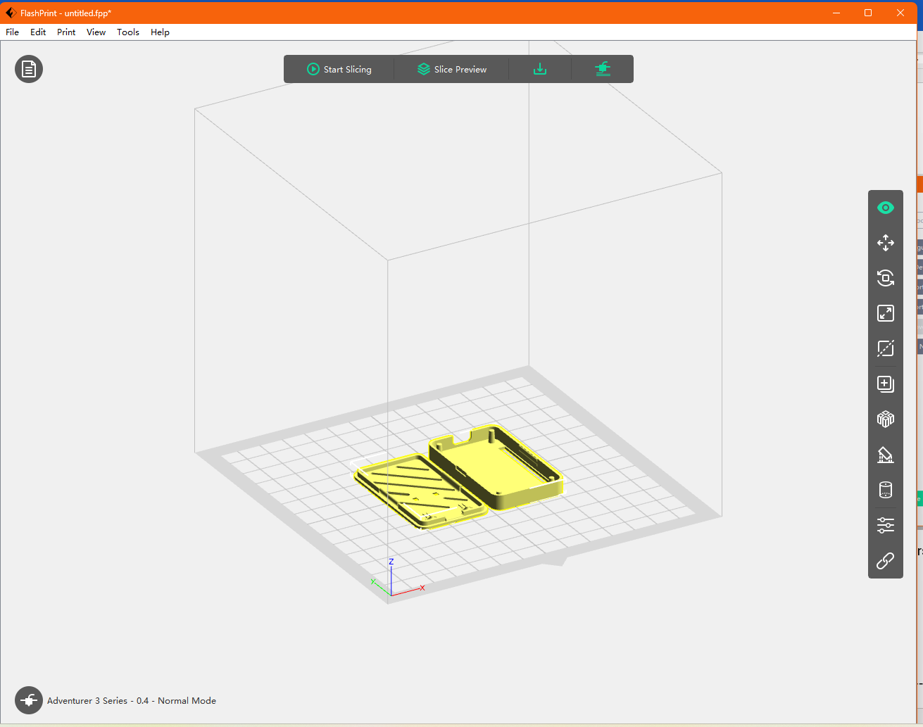

Click on the green down arrow in the dark bar at the top of the screen and the File Save dialog box will open.

Ensure “Save as type” is set to *.gx, ensure the file path is set to your USB flashdrive and press Save.

Your printable file is now saved to the USB drive.

1. [Chemical welding of polymer networks - ScienceDirect](https://www.sciencedirect.com/science/article/abs/pii/S2468519422000325#:~:text=Chemical%20welding%20as%20an%20attractive,molecules%20at%20the%20contacting%20surfaces.)